

VIETNAM NATIONAL UNIVERSITY HO CHI MINH CITY HO CHI MINH CITY UNIVERSITY OF TECHNOLOGY
FACULTY OF MECHANICAL ENGINEERING MECHATRONICS DEPARTMENT



THESIS REPORT

ANALYSIS AND DESIGN OF SOCCER ROBOT

Student’s name: Bùi Việt Thắng
Phan Tiến Minh
Student’s ID: 1852750
1852581
Instructor: Dr. Phạm Công Bằng



Ho Chi Minh city, 2022

ABSTRACT
Soccer robot is a specialized autonomous robot and mobile robot that is used to play variants of soccer system, Soccer robot competition designed to advance robotics and Artificial Intelligence research through friendly competition. The main organized competitions are RoboCup or FIRA tournaments played each year. Based on the existing conceptual design, this thesis will improve and develop differential wheeled soccer robot in practice.
This project includes 7 chapters as follows:

CHAPTER 1: INTRODUCTION – The overview about the soccer robot competitions and leagues.
CHAPTER 2: DESIGN SELECTION – Design the modules purpose and select the working principles and corresponding components for each module.
CHAPTER 3: MECHANICAL DESIGN – The calculation and selection of mechanical components for the mechanical components.
CHAPTER 4: ELECTRICAL DESIGN – Design the electrical system and selection of the remaining electrical components.
CHAPTER 5: KINEMATIC MODEL AND CONTROL SYSTEM OF THE ROBOT – Analyze robot system and Select the design of the suitable control system for each module.
CHAPTER 6: VISION SYSTEM – Recognize ball and robot by image processing
CHAPTER 7: PATH PLANNING ALGORITHM –
CHAPTER 8: CONCLUSION AND RECOMMENDATION – Evaluate the system and propose plans for future improvement.

CHAPTER 1: OVERVIEW

Introduction
In recent years, using mobile robots in the technical, industrial, and educational applications has been increased. Robotics is gaining popularity among younger generation, which is quite evident by the tremendous increase in robotic competitions all over the world.
Soccer also football nowadays becomes the most favorable sport in the world. Nothing unusual if robot soccer becomes more popular robot competition over the last decade. In 1993, Alan Mackworth proposed the idea of robot soccer game, which promotes the full integration of the research into artificial intelligence and robotics. There are some international soccer robot organizations who divide the competitions into several leagues, each of these leagues focus on the different technologies. Nowadays, there are 2 main international associations: RoboCup and FIRA.
RoboCup is an annual international robotics competition proposed [1] and founded in 1996 by a group of university professors (including Hiroaki Kitano, Manuela M. Veloso, and Minoru Asada). The aim of the competition is to promote robotics and AI research by offering a publicity appealing – but formidable – challenge.
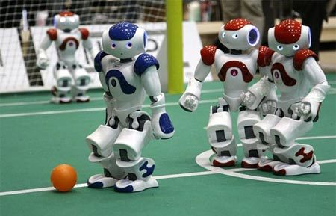
Fig 1.1 Standard form robot compete in soccer match the RoboCup 2009 in Graz, Australia [1]
The focus of the Robo Cup competition is the game of football/soccer, where the research goals concern cooperative multi-robot and multi-agent systems in dynamic adversarial environments. At this time, RoboCup’s leagues has divided into 5 leagues: Humanoid, Standard Platform, Middle Size, Small Size and Simulation. Fig 1.1 shows the NAO robot from SoftBank Robotics (The RoboCup Standard Platform League).

1.2 Soccer robots and teams

1.2.1 RoboCup Soccer Humanoid League
Robots participating in the Humanoid League competitions must have a human-like body plan. They must consist of two legs, two arms, and one head, which are attached to a trunk.
Robot must act autonomously and communicate only via (wireless) network
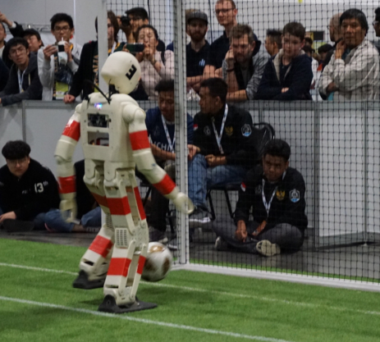
Fig 1.3 Team NimbRo, winner of the Best Humanoid Award 2019[2]

1.2.2 RoboCup Standard Platform League (NAO)
Standard Platform League is a RoboCup robot soccer league, in which all teams compete with identical robots. The robots operate fully autonomously, there is no external control, neither by humans nor by computers [4]. The teams play on a green field with white lines and goal posts, with no other landmarks, and the ball consists in a realistic white and black soccer one. These game characteristics generate a very challenging scenario , which allows improving the league every year.[5]
All teams must use black, gray, red, blue, or orange plated NAO humanoid robots manufactured by SoftBank Robotics. No additional hardware is permitted including off-board sensing or processing systems.
The robot can communicate in 2 ways: Wireless communications and non-wireless communications.
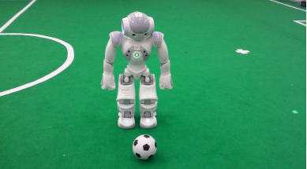
Fig 1.4 A NAO and official ball [3]

1.2.3 RoboCup Middle Size Robot League
In RoboCup MSL teams of 5 fully autonomous play soccer with a regular size FIFA soccer ball. Teams are free to design their own hardware but all sensors have to be on-board and there is a maximum size and weight for the robots. The research focus is on mechatronics design, control and multi-agent cooperation at plan and perception levels.
The projection of the robot’s shape onto the floor fits into a square of size at least 30cm × 30cm and at most 52cm × 52cm.
Communication between the robots of a team using wireless. Communication between the robots and one remote computer system (herein after referred as Base Station) is also allowed.
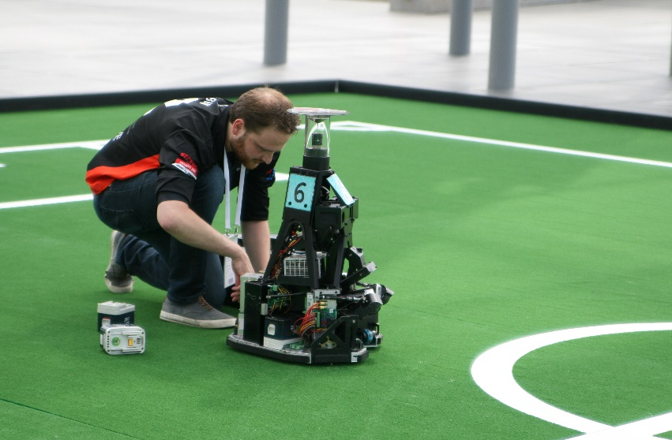
Fig 1.4 RoboCup MSL Leipzig, Germany (2016) [4]

1.2.4 RoboCup Junior League
Robots must be constructed and programmed in a way that their movement is not limited to only one dimension (defined as a single axis, such as only moving in a straight line). They must move in all directions, for example by turning. The size of the robot is 4cm diameter round.
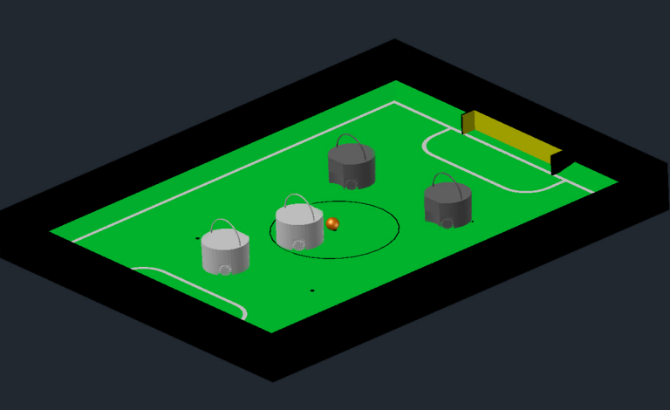
Fig 1.5 Two teams of two robots with an orange ball on a RoboCupJunior Soccer field
Robots are not allowed to use any kind of communication during gameplay unless the communication between robots is via Bluetooth class 2 or class 3 or via any other device that communicates using the 802.15.4 protocol (e.g., ZigBee and XBee).

1.3 IEEE Very Small Sized Soccer (VSSS)
The IEEE Very Small Size Soccer (VSSS) is a robot soccer competition in which two teams of three small robots play against each other. During the game, the main task for each team is to navigate on the field, moving the ball to score goals. Once the match starts, the robots cannot receive any human interaction, except during the break time. An image of the VSSS field is shown in Fig 1.6.
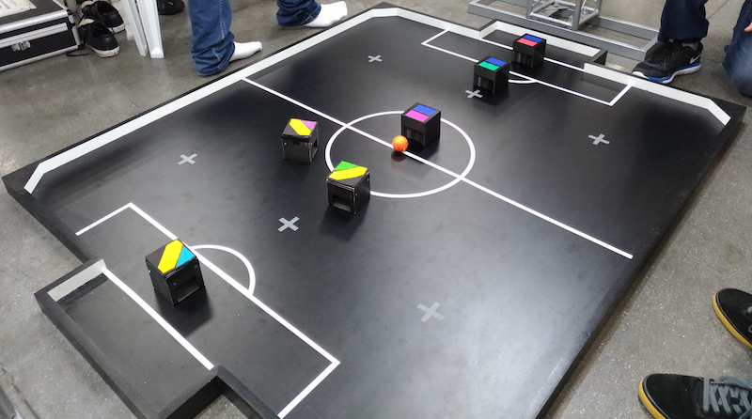
Fig 1.6 IEEE Very Small Size RoboCup Soccer in the Latin American and Brazilian Robotics Competition (LARC/CBR) [2]
1.3.1 The field and the ball
A black (non-reflective) rectangular wooden playground, 150cm x 130cm in size with 5cm high and 2.5 thick with sidewall will be used. The topsides of the sidewalls shall be black in color with the walls painted in white (side view). Solid 7cm X 7cm isosceles triangles shall be fixed at the four corners of the playground to avoid the ball getting cornered. The surface texture of the board will be that of a ping pong table.
The field of play shall be marked as shown in Figure 1.7. The center circle will have a radius of 20cm. The arc, which is part of the goal area, will be 20cm along the goal line and 5cm perpendicular to it. The major lines/arcs (centerline, goal area borderlines and the center circle) will be white in color and 3mm in thick. The free ball (Law 13) robot positions (circles) shall be marked in gray or white color.
The goal shall be 40cm wide with 10cm of depth. Posts and nets shall not be provided at the goal. This 10cm go beyond the 150cm of the field. The goal line is the line just in front of the goal which is 40cm long. The goal areas shall comprise of areas contained by the rectangle (sized 70cm X 15cm in front of the goal) and the attached arc (20cm in parallel to the goal line and 5cm perpendicular to it).
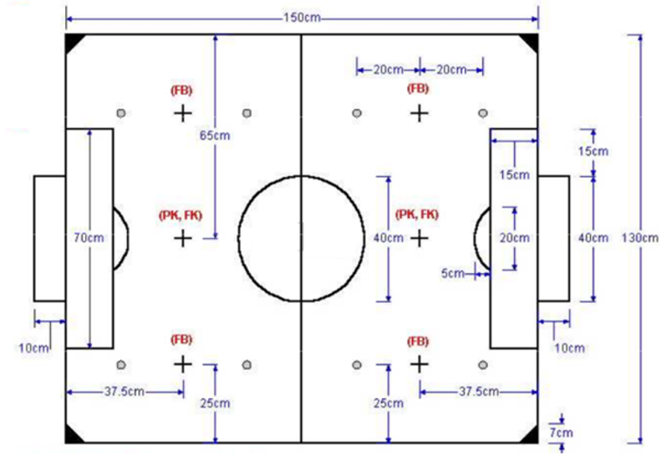
Fig 1.7 Arena dimensions
An orange golf ball shall be used as the ball, with 42.7mm diameter and 46g weight. To avoid vision problems, the ball will be provided by the competition. The field shall be indoors. The lighting condition in the competition site shall be fixed around 1000 Lux.
1.3.2 The players
A match shall be played by two teams, each consisting of a maximum of three robots. One of the robots can be the goalkeeper. Three human team members, a” manager”, a” coach” and a” trainer” shall only be allowed on stage. One host computer per team, mainly dedicated to vision processing and for location identifying, can be used.
The size of each robot shall be limited to 7.5cm x 7.5cm x 7.5cm. The height of the RF communication antenna will not be considered in deciding a robot’s size. The robots should wear uniforms and the size of which shall be limited to 8cm x 8cm x 8cm. A uniform cannot be part of the robot, i.e., the robot must be able to play a game even without the uniform.
The topside of a robot must not be colored in orange, white or gray nor must not be colored with more than two colors different from black and the team color. A color patch either blue or yellow, as assigned by the organizers, will identify the robots in a team. All the robots must have, visible on their top, a solid region of their team color patch, blue or yellow. This region can be of any shape but must be able to contain (at least) a square with 3.5 cm of side or a circle with 4 cm of diameter. A team’s identification color will change from game to game, and the team color patch used should be detachable. When assigned with one of the 2-team colors (blue or yellow), the robots must not have any visible patches of those colors used by an opponent team. Note: The teams are recommended to prepare a minimum of double blue and yellow patches for competition. The teams are also recommended to prepare a minimum of 6 different color patches, other than blue and yellow, for individual robot identification.

Robot Soccer System by a group of K17 OISP mechatronics students
1.4.1 Overview
A study “Study and Implement of a Robot Soccer System based on the CDIO approach” begun developed by a group of K2017 OISP mechatronics students (Tran Tieu Binh – team leader, Cao Tri Trieu, Dang Minh Quan and Lam Hung Minh). After six months of research and experimentation in the context of the COVID-19 epidemic in Ho Chi Minh City, the team sometimes ran the model directly at the school, sometimes had to write code remotely due to the global social distance in the city.
Overcoming many obstacles with expert guidance from Dr. Pham Cong Bang - Lecturer in Mechatronics Department, a group of OISP students completed “Study and Implement of a Robot Soccer System based on the CDIO approach” (thesis title) and was accepted to participate in the project. attend the 24th International Conference on Mechatronic Technology (ICMT 2021) hosted by Singapore online from December 18-22, 2021 showed in fig. 1.8.

Fig 1.8 The 24th International Conference on Mechatronics Technology (ICMN 2021) will be held online by Singapore from December 18-22, 2021.
1.4.2 Prototype development
The robot is required to fit into a 100 × 100 × 100 (mm) space, driven by two wheels and the robot’s structure must be modular. In this study, the soccer robot is a differential drive mobile platform. This structure consists of two driving wheels mounted on a common axis, and each wheel can independently be driven either forward or backward. The center wheel axle is a good design choice, the robot rotates around its center, which supports robot detection later in vision. The robot could be well-balanced by adding two small ball caster wheels on the two sides of the axle. The robot soccer separating in four layers as highlighted in the fig 1.9.
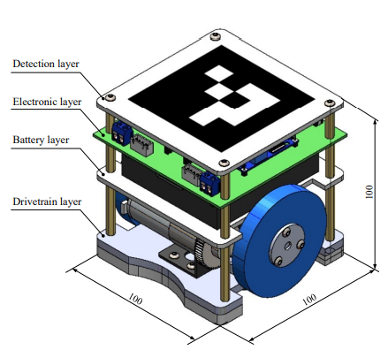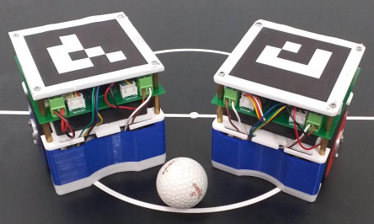
Fig 1.9 Final design of the robot [6] Fig 1.10 Two soccer robots and the ball [6]
1.4.3 Experiment result
From the design above, two robots are created as in Fig. 1.10. When applying the control method, these robots can achieve the accuracy of ±10◦ for pure rotation and ±50 mm for pure translation. The vision-based robot localization, which makes sure the system works as desired, has been deployed. The experimental results with respect to time illustrates the success of the controller system. However, the accuracy performance of the system is not very good, which definitely limits the robot ability in team coordination. Therefore, together with the simultaneous motion between the rotation and translation that makes the robot move smoothly, the improvement in system performance will be our future works.

Objective and Scope
1.5.1 Goal
Based on foreign projects and previous project made by Tran Tieu Binh and his friends, the main objective in this thesis is implementing the prototype and kinematic of the robot, computer vision algorithms, object recognition and motion control algorithm of the robot to improve the movement of the previous soccer robot system.
1.5.2 Objective
a) Calculate and Design soccer robot system
- Design half of the soccer field (80cm x 100cm)
- Design computer vision system
- Implement and design a different wheeled robot
- Design electrical circuit
- Calculate transfer function and PID control system for the motor
- Experiment and evaluate the accurate of the control system based on the response of the robot
b) Computer vision for robot and ball localization
- Research the algorithm like Hough Circle, Canny Edge detection, Aruco detection to calculate position of the robot and the ball
- Implement and design flowchart and write code program for computer vision system
c) Develop the motion control system
- Research Design the communication between the robot and PC via WIFI
- Research path planning algorithm to shoot the ball into the goal
- Experiment the robot to shoot a ball
1.5.3 Thesis scope
- Within the objective, the scope is limited for: The half soccer field have a dimension of 1000mm x 800mm, flat surface made of PVC plastic. Figure 1.11 is shown the dimension of half the soccer field for the robot.
- A colored golf ball shall be used as the ball, with standard weight and diameter.
- The robot prototype is differential wheel robot with 2 main motor and 1 free turning wheel.
Fig 1.11 Dimension of a soccer field
- A colored golf ball shall be used as the ball, with standard weight and diameter.
- The robot prototype is differential wheel robot with 2 main motor and 1 free turning wheel.
1.5.4 Thesis’s chapters
- Chapter 2: Design mechanical part of the soccer robot
- Chapter 3: Design electrical circuit for the robot
- Chapter 4: Implement the computer vision of the soccer robot system
- Chapter 5: Design the motion control of the robot to shoot a ball into a goal
- Chapter 6: Evaluate the project.

CHAPTER 2: SYSTEM PRINCIPLE AND COMPONENTS SELECTION

2.1 Mechanical principles selection
The number of wheels using in most type of mobile robot and soccer robot play an important role in analyzing the dynamic and motion control of the robot.
Based on the purposes and characteristics of the robot, the number of using wheel can be modified. However, soccer robots from all over the world currently have 3 popular types of mechanism.
Table 2.1 Comparison of some suitable principle
Principle | Advantages | Disadvantages
 | Small size and easy to install. It allows the robot to spin around a pivot point, which is more flexible than the others | Lack of passive wheel. Self-balance algorithm should be implemented or accept the friction force created by 1 edge of the robot base and the surface.
 | Easy to rotate, flexible in moving | Complex transmission drive, need 3 independent motors. Robot can be overturned when it rotates suddenly
 | Small size and easy to install. It allows the robot to spin around a pivot point. | Passive wheel can lead to undesired movement.
 | Easy to install, can rotate with high speed, high aesthetic | Difficult to synchronize the speed of 4 motors while on straight line. Need a lot of space to install.
 | Can move multi-direction with rotating. High flexibility | Complex transmission drive, need 4 independent motors.

Conclusion
The purpose of this thesis is to fabricate a small size soccer robot (100 x 100 x 100 mm) and light weight. Therefore, the robot platform consist of 2 driving wheels at the rear and one ball wheel in the front is selected. The ball wheel is suitable with our flat plane platform as it provides 1 contact point, which produce less friction compared to other type of wheel, reducing the occurrence of slipping that produce noise for the control algorithm.
Fig 2.1 The chosen soccer robot mechanism
The mechanism is no need to implement self-balanced algorithm. However, the passive wheel might cause undesired movement, increasing the complexity of kinematic and dynamic analysis.
Fig 2.2 Schematic diagram of soccer robot
2.2 Wheel selection
There are 3 popular types of wheels using in mobile robot industry: standard/fixed wheel, castor wheel and Omni wheel. However, the chosen mechanism is coaxial shaft system, so they must be driving wheels. Hence, castor wheel option is eliminated.
Table 2.2 Comparison of wheels
 | Fixed wheel | Omni wheel
Advantages | - Small size  - Better traction  - Cheap | - High flexibility  - 3 degree of freedom  - Small friction
Disadvantages | - Poor flexibility  - 2 degree of freedom | - Slip phenomenon is easy to occur  - Big size  - Expensive

According to the scope, Omni wheel is not necessary because flexibility movement is no need to be created. Furthermore, fixed wheel allows the robot to move faster because of the ability of traction.
2.3 Motor selection
DC encoder motor is used in this project due to the small size, suitable for the design requirement.
2.4 Controller selection
The purpose is collect, transmit and receive data:
- Control motor
- Send data back to PC

Table 2.3 Comparison of controller
Option | Illustration | Advantages | Disadvantages
Microcontroller | 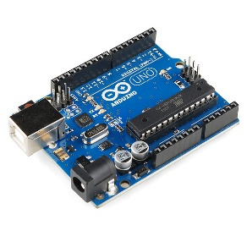 | - High performance.  - Easy to communicate without the presence of other expensive devices | - Poor technology can lead to anti-interference.
PLC | 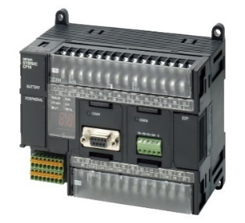 | - Designed to be implemented in industrial environment easily  - Built-in communication for I/O remote inputs and outputs, instrumentation  - Easily controlled by logical adjustments via software, no adjustments are required to the wire connections. | - Expensive  - Complex wiring  - Difficult to alternate  - Difficult to find out error
Conclusion: Choose microcontroller option because:
- High performance.
- Communicate UART easily.
- Small size.
- Cheap.
- Many available modules in market can be chosen based on requirement.

Table 2.4 Compare and select microcontroller
Option | Illustration | Characteristics
STM32 | 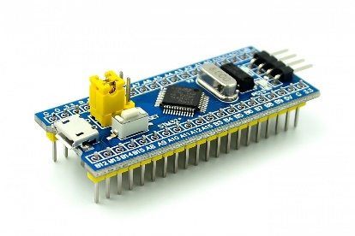 | - Full of communication protocol, interrupt, timers, …  - Design software easier because of IDE, productivity can be also optimized.  - Low investment
PIC | 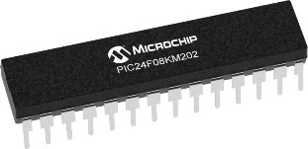 | - Many available communication protocols, interrupt, timers, …  - Expensive
Arduino | 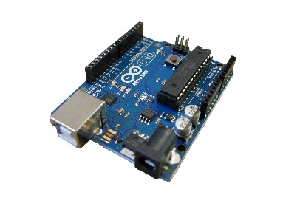 | - Full of communication protocols, interrupt, timers, …  - Design software easier because of IDE, productivity can be also optimized.  - Low investment
ESP32 NodeMCU | 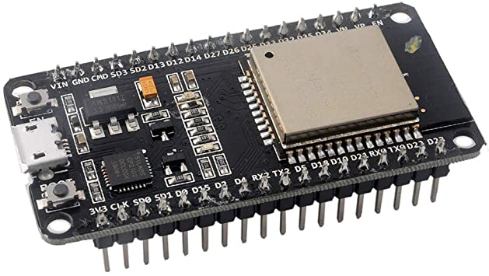 | - Full of communication protocols, interrupt, timers, …  - Design software easier because of IDE, productivity can be also optimized.  - Low investment  - Specially, Wi-Fi communication protocol is available.
Conclusion: Choose ESP32 NodeMCU, because it not only satisfies design requirements, but also has IDE and support libraries which makes designing software easier. Moreover, Wi-Fi communication protocol is available, makes it convenient in using process.

2.5 Transmission design
The control system has 2 main tasks: receive data from PC and control speed of 2 motor. In order to complete these tasks, wired or wireless communication can be implemented. Because the robot should move constantly, so wireless communication is preferable.

Table 2.5 Wireless communication is widely used in mobile industry
Option | Characteristics
Bluetooth  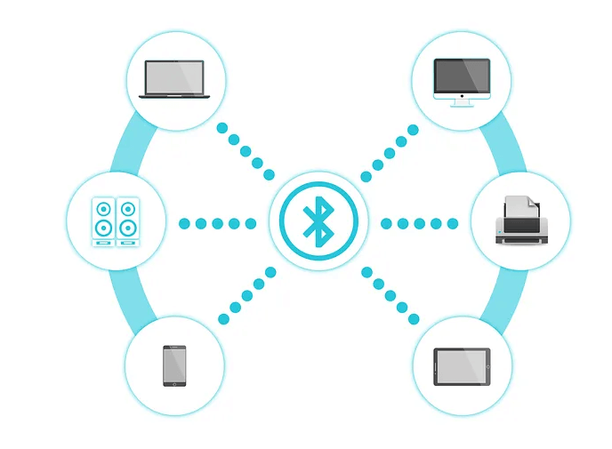 | - Low bandwidth.  - Suitable for communication among a small number of devices.  - Narrow range.
Wi-Fi  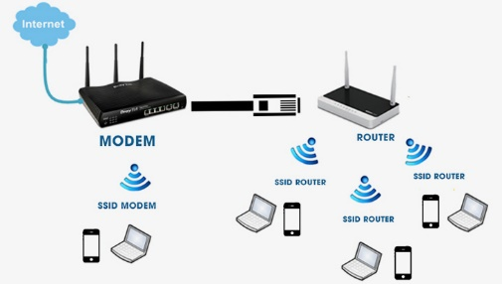 | - High bandwidth.  - Support for a huge number of users.  - Large range.  - Utilized by lots of industrial environment

Based on technical requirements, Wi-Fi communication is chosen

CHAPTER 3: MECHANICAL DESIGN
Based on the scope, the design parameters need to be followed as below
- Maximum size: 100x100x100 mm
- Mass $≤$ 1kg
- Velocity: 1m/s
- Acceleration: 1$m/s^{2}$
3.1 Select robot’s wheels
Based on the soccer robot mechanism chosen in previous chapter, the wheels is designed and printed 3D.
- Wheel diameter: $d_{a}=84 mm$.
- Wheel width: $w_{a}=3 mm$.
For the passive wheel, select small universal castor wheel with the specifications:
- Wheel width: $d_{b}=22 mm$.
- Wheel height: $h_{b}=15 mm$.
3.2 Select an electric motor
Figure 3.1 Force analysis diagram
* Moment of inertia of the wheel:
$$I=\frac{1}{2}mR^{2} (3.6)$$
* Equalize the moment of inertia around the center of the wheel:
$$τ-F_{ms}R=Iγ (3.7)$$
$$↔τ=Iγ+F_{ms}R (3.8)$$
* Condition that the wheel is rolling without slipping when motor shape rotating:
$$F_{ms}≤μN=μP(3.9)$$
$$↔τ≤μPR+Iγ (3.10)$$
$$↔τ≤\frac{1}{2}mR^{2}γ+μmg×R (3.11)$$
* The power of the wheel:
$$P_{wheel}=τω (3.12)$$
* Required power of motor:
$$P_{motor}=\frac{P_{wheel}}{η} (3.13)$$
In which:
- m = 1 kg Total mass
- µ = 0,05 Coefficient of friction
- R = 42 mm Wheel radius
- $F_{ms}$ Friction force
- γ=a/R Angular acceleration
- a = 0.1$m/s^{2}$ Desired acceleration
- g = 9,81$m/s^{2}$ Gravitational acceleration
- $ω$ Angular velocity
- $η$ Transmission efficiency

Table 3.1 Desired parameter
Parameter | Value
Desired velocity | 1 (m/s)
Desired acceleration | 1 (m/$s^{2}$)
Wheel radius | 42 (mm)
Friction coefficient | 0.05
Safety coefficient | 1.3

Hence, the moment of inertia of the working shaft:
$$τ=\frac{1}{2}×1×{\left({42.10}^{-3}\right)}^{2}.\frac{1}{{42.10}^{-3}}+{0,05.×1×9.81×42.10}^{-3} (3.14)$$
$$=0.02 Nm$$
Number of revolutions of the working shaft:
$$n_{shaft}=\frac{60v}{πD}=\frac{60×1}{π×{84.10}^{-3}}=222.2 m/s(3.15)$$
The transmission ratio of spur gear is 0.5, hence minimum motor rotation speed is:
$$n_{motor}=u_{r}×n_{shaft}=0.5×222.2=111.1 m/s$$
The transmission system consists of 1 pair of spur gears, 1 pair of bearings. Hence the efficiency of the system can be calculated as below:
$Ƞ=Ƞ_{spurgear}Ƞ_{bearing}$ (2.9 p.19[1])
where:
$Ƞ_{spurgear}=0.94$: Efficiency of a pair of spur gears
$Ƞ_{bearing}= 0.95$: Efficiency of a pair of bearings
The efficiencies of gears and bearing are chosen from table 2.3 p.19[1], given that the gears not covered, it is suggested that choosing the value in a specific range; given no practical experiences, all the middle values from those ranges are chosen for better accuracy.
- $Ƞ= 0.94×0.95 = 0.83$
Choose safety coefficient of motor: $s_{f}=1,3$
Moment of inertia of the motor shaft:
$$T=\frac{τs_{f}}{ηu_{r}}=\frac{0.02×1.3}{0.83×0.5}=0.074 Nm (3.16)$$
Choose GA25 gear motor DC with speed encoder
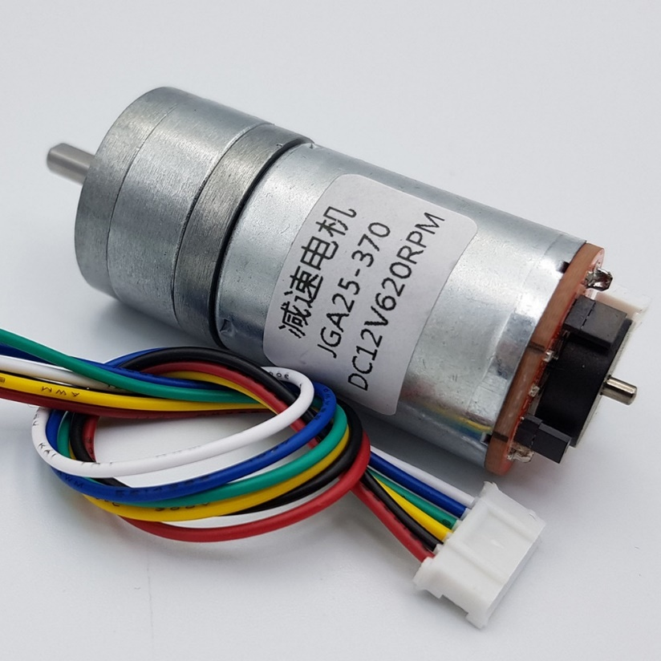
Fig 3.2 GA25 gear motor DC with speed encoder
Table 3.2 Motor parameter
Parameter | Value
mass | 0.1 kg
Voltage | 3 - 12 V
Motor speed | 200 rpm
Moment of inertia | 420 Nmm
Power | 13.2 W

Recalculate the system:
Average speed of robot:
$$v_{ct}=\frac{\left(n_{ct}πD\right)}{60}=\frac{200×π×{84.10}^{-3}}{60}=0.015\frac{m}{s}(3.17)$$
Power of motor shaft:
$$P_{ct}=\frac{T.π.n_{ct}}{30}=\frac{0.074×π×200}{30}=1.54 W<P_{đm}=13.2W (3.18)$$
Hence, the chosen motor satisfies the requirement
Power of working shaft:
$$P_{wheel}=P_{ct}×Ƞ=1.54×0.83=1.28 W$$
Torque of working shaft:
$$T_{shaft}=\frac{60×P_{wheel}}{2π×n}=0.0305 Nm$$
3.3 Calculate to select car dimension
Figure 3.3 Force diagram of the robot (top view)
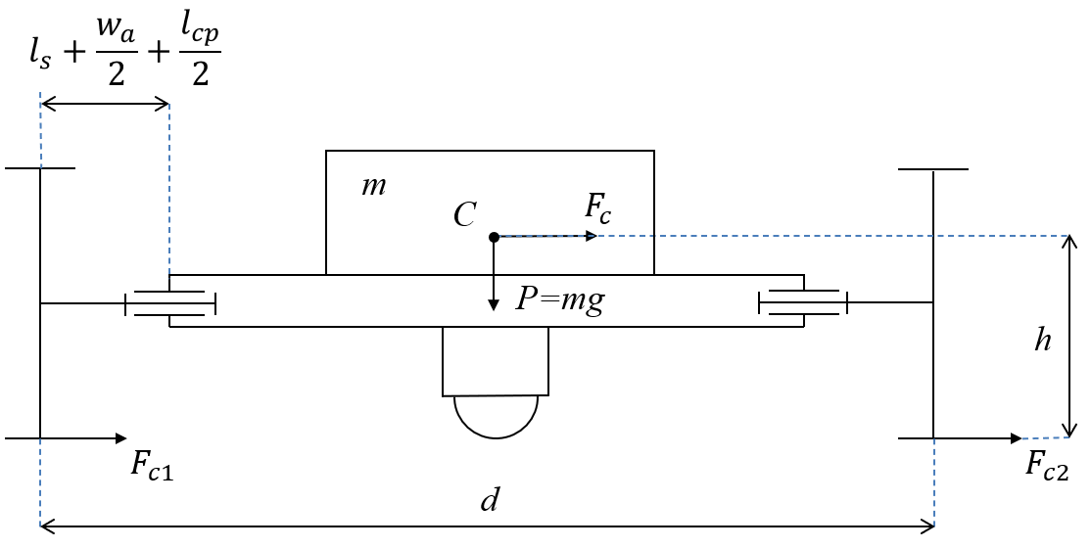
Figure 3.4 Force diagram of the robot (front view)
Based on figure 3.2, 3.3, to prevent the car from rolling over, this condition must be satisfied:
$F_{i}h<Pd_{CA}$
$\left(\sqrt{{\left(m{\left(\frac{v}{R}\right)}^{2}R\right)}^{2}+v_{c}^{2}}\right)h<mg\frac{d_{EC}d_{HB}}{d_{EH}}$
$\left(\sqrt{{\left(m{\left(\frac{v}{R}\right)}^{2}R\right)}^{2}+v_{c}^{2}}\right)h<mg\frac{l_{1}d_{HB}}{l_{1}+l_{2}}$
$0.1×{\left(\frac{1}{0.4}\right)}^{2}×0.4h<0.1×9.81×\frac{0.02×0.05}{0.024}$
$6.25×h<0.4$
$h<0.064\left(m\right)=64 mm$
Hence, height of center of the robot should be under 64mm to satisfy the requirement.
3.4 Design gear transmission
3.4.1 Design data
Power of helical gear: P = 9.63 W
Transmission ratio of helical gear: $u$= 0.5
Revolution of driving gear: $n_{1}$= 200 rpm
Revolution of driven gear: $n_{2}$ = 400 rpm
3.4.2 Choosing material
According to table 6.1 p.92[1], without any specific requirement, choose widely used material type I material (HB ≤ 350), to facilitate the gear’s teeth cutting procedure, make it more accurate, lessen the need for stronger material for shafts, but also provide high allowable stress; $H_{1}$ ≥ $H_{2}$ + (10 … 15) HB so as to reduce the friction between gears:
For the driving gear we choose steel 45 quenched with rigidity $H_{1}=185HB$; ultimate strength $σ_{b}$ = 650 MPa; yield limit $σ_{ch}$ = 380 MPa
For the driven gear we choose steel 45 quenched with rigidity $H_{2}=170HB$; ultimate strength $σ_{b}$ = 600 MPa; yield limit $σ_{ch}$ = 340 MPa
3.4.3 Gear drive parameters
Table 3.3 Gear drive parameters
Geometry parameters | Spur gear  drive | Driving gear | Driven gear
Center distance: a (mm) | 25 | - | -
Torque: T (Nmm) | - | 460 | 205
Transmission ratio: u | 0.5 | - | -
n (rpm) | - | 200 | 400
Module: m (mm) | 1 | - | -
Teeth number: z (teeth) | - | 34 | 17
Teeth angle: $β$ (°) | 0 | - | -
Pitch circle diameter: d (mm) | - | 34 | 17
Crest circle diameter: $d_{a}$ (mm) | - | 36 | 19
Dedendum diameter: $d_{f}$ (mm) | - | 31.5 | 14.5
Gear width: b (mm) | - | 6 | 7
Lewis factor: Y | - | 0.371 | 0.302
3.4.4 Strength check
Based on Lewis strength check standard:
$$σ=\frac{F_{t}×P}{b×Y}=\frac{4.12×1/1}{7×0.302}=1.94<\frac{σ_{b}}{3}=200 Mpa$$
Lewis factor can be check in table 12.1 of reference []
Hence, the driven gear strength satisfies the requirement.
The calculated tangential stress:

$σ_{H}=\frac{Z_{M}Z_{H}Z_{ε}}{d_{1}}\sqrt{\frac{2T_{1}K_{H}\left(u+1\right)}{b_{w }u}}$ (6.58 p.115[1])

$$=\frac{190×1.76×0.79}{34}\sqrt{\frac{2×460×1.23×\left(0.5+1\right)}{7×0.5}}=209.7 MPa$$
where:
$Z_{H}$: coefficient of contact area $Z_{H}=\sqrt{\frac{2\cos{β}}{\sin{2}α_{tw}}}=\sqrt{\frac{2cos0}{\sin\left(2×16.56°\right)}}≈1.76$
$Z_{ε}$: contact length coefficient, when $ε_{b}$ < 1 use the following equation:

$Z_{ε}=\sqrt{\frac{1}{ε_{α}}}=\sqrt{\frac{1}{2.14}}=0.79$ (6.36c p.105[1])
where:$ε_{α} = \frac{\sqrt{d_{a1}^{2}-d_{b1}^{2}}+\sqrt{d_{a2}^{2}-d_{b2}^{2}}-2α_{w}sinα_{tw}}{\frac{2πmcos\left(α_{t}\right)}{\cos\left(β\right)}}$ (6.47 p.105[1])
$$=\frac{\sqrt{{36}^{2}-{31.5}^{2}}+\sqrt{{19}^{2}-{16}^{2}}-2×25×\sin\left(16.56°\right)}{2π×1×\frac{\cos\left(16.56°\right)}{\cos\left(0°\right)}}=2.14$$

(6.48 p.105[1])
$$ε_{b}=\frac{b_{w}sinβ}{mπ}=0<1$$
$Z_{M}=190MPa^{\frac{1}{3}}$: material mechanical property coefficient, chosen based on table 6.5 p.96[1], given that the gears are made by steel
$K_{H}$: coefficient of load

$$K_{H}=K_{Hβ}K_{Hv}K_{Hα}=1×1.16×1.038≈1.22$$
where:
$K_{Hβ}= 1$ is coefficient of undistributed load on gear width
$K_{Hα}= 1.13$is undistributed load coefficient
$K_{Hv}=1+\frac{v_{H}b_{w}d_{w1}}{2T_{1}K_{Hβ}K_{Hα}}=1+\frac{0.371×7×34}{2×460×1×1.13} ≈1.088$
with:$v_{H}=δ_{H}g_{0}v\sqrt{\frac{a_{w}}{u}}=0.002×73×0.36×\sqrt{\frac{25}{0.5}} =0.371$
$δ_{H}=0.002$ is coefficient of contacting errors, chosen based on table 6.15 p.107[1] given that gear with inclined teeth and ${HB}_{2}≤350HB$
${ g}_{0}$ = 73 is coefficient of teeth module error, chosen based on table 6.16 p.107[1] given that the degree of accuracy is 9, module $≤$ 3.55.
Precisely calculating the allowable contacting stress:

$\left[σ_{H}\right]=\left[σ_{H}\right]Z_{R}Z_{V}K_{xH}=340×1×0.77×1=260.6 MPa$ (6.1a p.93[1])
where: $\left[σ_{H}\right]$ on the right side of the equation is calculated in part II.5 above,
$$\left[σ_{H}\right]=340 MPa$$
Checking the value of tangential stress:

$$σ_{H}\sqrt{K_{lv}}=209.7×\sqrt{1}=209.7 MPa<\left[σ_{Hmax}\right]= 952 MPa$$
$→$This satisfies the strength condition
Determine the bending stress for driving gear:

$σ_{F1}=\frac{2T_{1}K_{F}Y_{ε}Y_{β}Y_{F1}}{b_{w}d_{w1}m}$ (6. p.108[1])

$$=2×460×1.68×0.47×1×\frac{4.26}{\left(7×34×1\right)}=12.5MPa$$
where: $K_{F}=K_{Fβ}K_{Fα}K_{Fv}=1.01×1.37×1.22=1.62$is coefficient of load affected bending (the other parameters are chosen and calculated above)
$Y_{ε}=\frac{1}{ε_{α}}= 1/2.14 = 0.47$ is the coefficient of meshing
$Y_{β}= 1- \frac{β}{140} = 1-0/140 = 1$ is the coefficient of teeth incline
$Y_{F1}=4.26$ is the coefficient of teeth type, chosen based on table 6.18 p.109[1] given the displacement coefficient x = 0 and the corresponding teeth of driving gear as calculated below:
$$z_{v1}=\frac{z_{1}}{\cos^{3}β}=34$$

$K_{Fv}=1+\frac{v_{F}b_{w}d_{w1}}{2T_{1}K_{Fβ}K_{Fα}}$ (6.46 p.109[1])

$$=1+\frac{4.07×7×34}{2×460×1.01×1.37} ≈1.22$$
where: the parameters are notated in the previous part
$$v_{F}=δ_{F}g_{o}v\sqrt{\frac{a_{w}}{u}}=1.11$$
Determine the bending stress for driven gear:

$σ_{F2}=\frac{σ_{F1}Y_{F2}}{Y_{F1}}=12.5×3.72/4.26 = 10.9 MPa$ (6.44 p.108[1])
where: $Y_{F2}=3.72$ is the coefficient of teeth type, chosen based on table 6.18 p.109[1], given the displacement coefficient x = 0 and the corresponding teeth of driven gear as calculated below
$$z_{v2}=\frac{z_{2}}{\cos^{3}β}=17$$
Calculating precisely the allowable bending stress for both gears:

$\left[σ_{F1}\right]=\left[σ_{F1}\right]Y_{R}Y_{s}K_{xF} = 190.3×1×1.08×1 ≈ 205.5 MPa$ (6.2a p.93[1])

$\left[σ_{F2}\right]=\left[σ_{F2}\right]Y_{R}Y_{s}K_{xF}= 174.9 ×1×1.08×1 ≈ 188.8 MPa$ (6.2a p.93[1])
where: $\left[σ_{F1}\right],\left[σ_{F2}\right]$on the right side of the equation is calculated,

$$\left[σ_{F1}\right]=190.3 MPa;\left[σ_{F2}\right]=174.9 MPa$$
$Y_{R}=1$ is coefficient of surface roughness (use gears had been through grinding process)

$Y_{s}=1.08- 0.0695\text{ln}\left(m\right)=1.08-0.0695\text{ln}\left(1\right)=1.08$ is coefficient of sensitivity to load
$K_{xF}=1$ is coefficient of gear size affected to bending stress (when $d_{a}≤400$)
Checking the bending stress:

$σ_{F1}K_{lv}= 235.2×1=235.2 Mpa<\left[σ_{F1max}\right]=304MPa$ (6.49 p.110[1])

$σ_{F2}K_{lv}= 232×1=232 Mpa<\left[σ_{F2max}\right]=272 MPa$ (6.49 p.110[1])
- Both gears satisfy the bending stress condition
3.5 Design shaft
Although the robot does not carry heavy workload, C45 steel is chosen to ensure the stability.
Tangential force:
$$F_{t12}=\frac{2T}{d_{w2}}=\frac{2×0.035}{0.017}=4.12 (N)$$
$$F_{t11}=\frac{2T}{R}=\frac{2×0.035}{0.042}=1.63 (N)$$
Centrifugal force:
$$F_{r12}=\frac{F_{t12}tgα_{tw}}{\cos{β}}=\frac{4.12 ×tg20^{∘}}{cos0°}≈9.217 N$$
$$F_{r11}=\frac{F_{t11}tgα_{tw}}{\cos{β}}=\frac{1.63 ×tg20^{∘}}{cos0°}≈3.64 N$$
Moment on shaft:

Force equation on x axis:

$$∑F_{X}={-F}_{X11}+F_{X12}-F_{r12}-F_{t11}=0$$

⬄${-F}_{X11}+F_{X12}=F_{r12}+F_{t11}=13.3 N$

Force equation on y axis:

$$∑F_{Y}=F_{Y11}-F_{Y12}+F_{r11}-F_{t12}=0$$

⬄$F_{Y11}-F_{Y12}=F_{t12}-F_{r11}=0.48 N$
Moment equation in Ozx plane at A:

$$∑M_{Ozx}={-F}_{r12}×7+F_{X12}×10-F_{t11}×16.5=0$$
- $-9.217×7+F_{X12}×10-16.3×16.5=0$
- $F_{X12}≈33.35 N$ ⇨ $F_{X11}=20 N$
Moment equation in Ozy plane at A:

$$∑M_{Ozy}=-F_{t12}×7+F_{Y12}×10-F_{r11}×16.5=0$$
- $-4.12×7 +F_{Y12}×10-3.64×16.5=0$
- $F_{Y12}=8.89 N$ ⇨ $F_{Y11}=9.37 N$
The other moments are calculated and presented in the diagram:
The most dangerous area is at C section, critical moment at C:
$$M_{td}=\sqrt{{M_{x}}^{2}+{M_{y}}^{2}}=\sqrt{{105.95}^{2}+{23.66}^{2}}=108.5 Nmm$$
Diameter at section C:
$$d≥\sqrt[3]{\frac{32M_{td}}{π\left[σ\right]}}=\sqrt[3]{\frac{32×108.5}{π×82.5}}=4.5 mm$$
Choose shaft’s diameter $ϕ=5$ mm
3.6 Select bearing
Because there is no axial force applied on shaft, so choose row ball bearing
Longevity:
$$L=\frac{60nL_{h}}{{10}^{6}}=\frac{60×400×10000}{{10}^{6}}=24(million revolution)$$
with: $L_{h}={10}^{4} h$ is longevity of bearings in hours
$n$ is the speed of shaft (rpm)
Force caused by bearing:
$$F_{r}=\sqrt{{F_{x}}^{2}+{F_{y}}^{2}}=\sqrt{{33.35}^{2}+{8.89}^{2}}=34.5 N$$
Dynamic load sustainability:
$$C_{d}=Q\sqrt[m]{L}$$
with: Q is notational load (kN)
$Q=\left(XVF_{r}+YF_{a}\right)k_{t}k_{d}$
with: $X$ is coefficient of centripetal load (chosen from table 11.4 p.215[1], based on practical coefficient e; for shaft I and II, e is chosen based on the equation i$F_{a}/C_{o}$, with i=1 is the number of rows of the bearing; $C_{o}$is the ability to sustain stable load, chosen from table P2.12 p.264[1]; for shaft I, $e=1.5tan⁡(α)$)
$Y$ is coefficient of axial load (chosen from table 11.4 p.215[1], the specifications for choosing are the same as$X$)
$V$ is coefficient of which ring rotate ($V=1$ when inner ring rotates)
$k_{t}$ is coefficient of temperature $k_{t}=1$ when temperature $θ=105°$
$k_{d}$ is coefficient of load specificity, $k_{d}=1$(chosen from table 11.3 p.215[1] for light impact load)
m is grade of the bending line, m = 3 for ball bearing
$→Q=\left(1×1×0.0345\right)×1×1=0.0345$ kN
Hence, $C_{d}=34.5×\sqrt[3]{24}=0.0995 (kN)$
Hence, choose bearing having $C>C_{d}$

